**Accounts info:**

Gateway of tally holds many features and Account Info is one of them through which we can provide Tally the details of our company’s account, which are Groups, Ledger and Voucher.

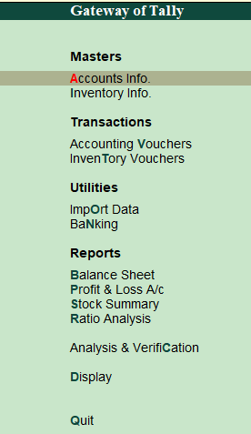

**Group**

The group is a collection of leaders of the same nature. Tally software automatically creates 28 groups that are used in the account chart.

**Creating single group** 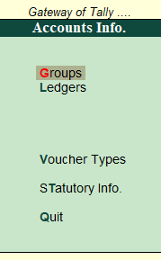

To create a single group, we have to go to tally and then click on the group. In the group, we click on a single group and then create.



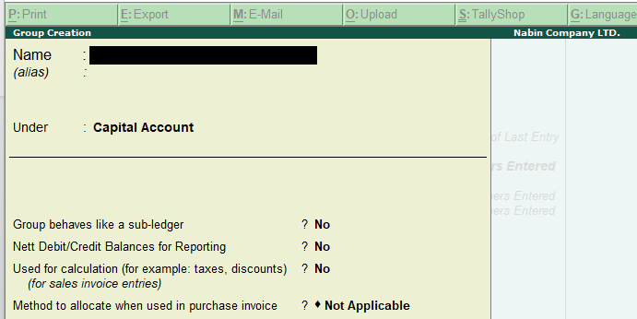

**Displaying of single group**

To display a single group, we have to go to tally and then click on the group. In the group, we click on a single group and then display.

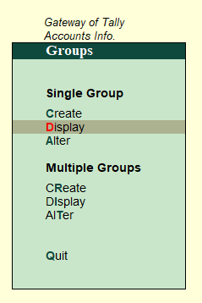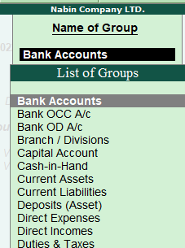

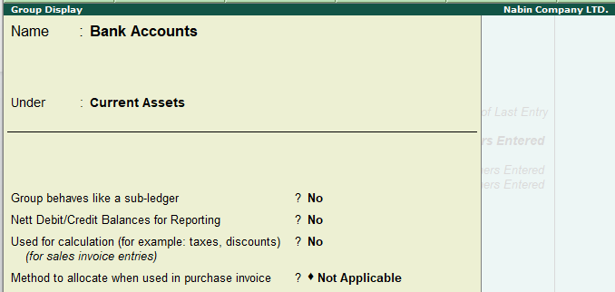

**Alteration of a single group**

We can simply alter the single group click on alter option available on a single group.

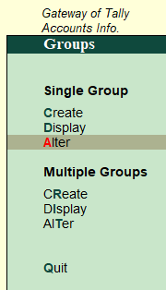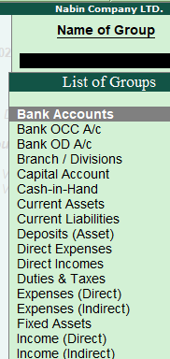

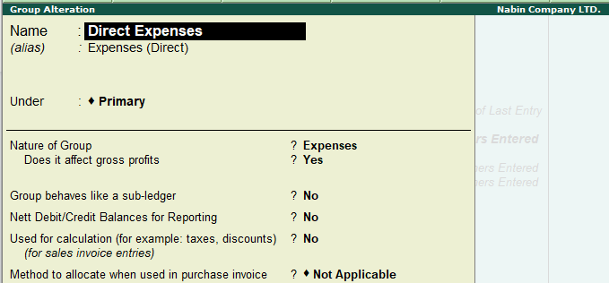

**Creating multiple groups**

click on multiple groups then click on create. After that fill in the detail and press enter.

.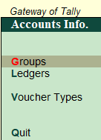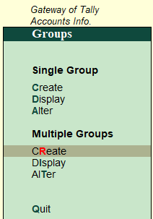

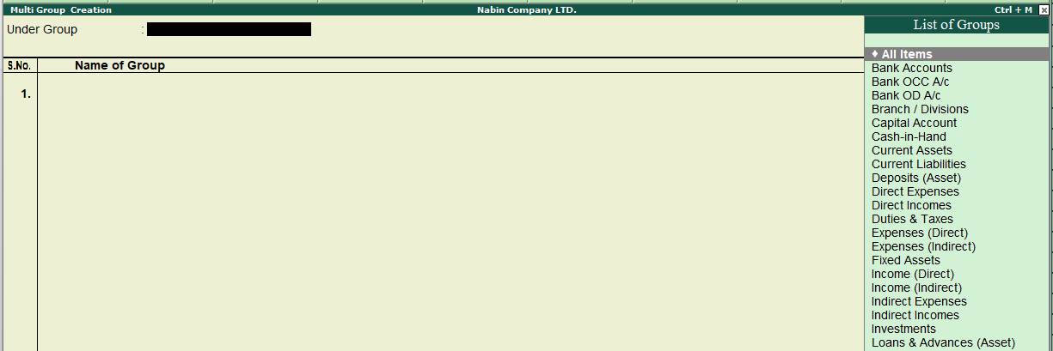

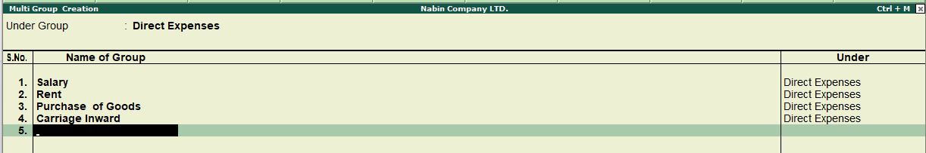

**Displaying multiple groups**

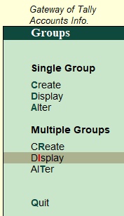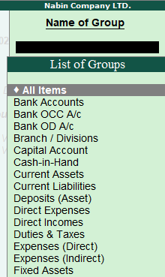

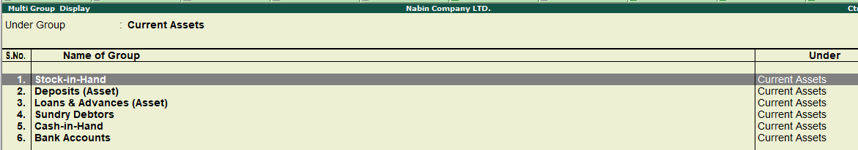

**Alteration of multiple groups**

We can alter multiple groups by clicking on alter option available on multiple groups.

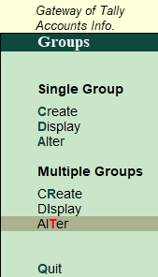 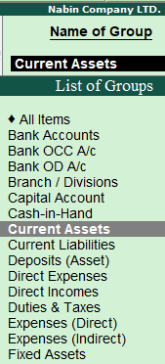

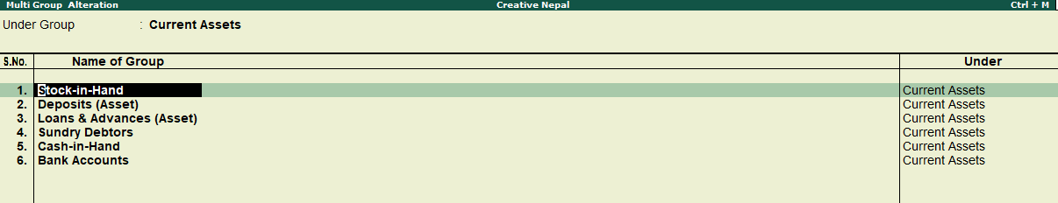

**Ledger**

The statement or book that records the transactions in one place to a particular subject to help determine the net result is known as a ledger. Ledger is the actual account head to identify your transactions and is used in all accounting vouchers. Ledger journal entries include accounts like cash, purchase, sales, investments, inventory, and other account heads. Without a ledger, it is difficult to record transactions. All ledgers have to be classified into groups.

**Ledger Creation**

**Single ledger Creation**

In tally by creating a single ledger, we can create individual ledgers at a time. To create a ledger we have to create a ledger each time

Steps

* Go to the gateway of tally
* Go to account info
* Click on the ledger
* Create a single ledger

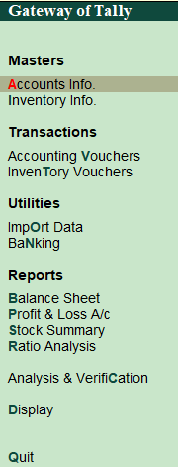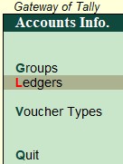

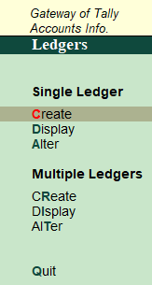

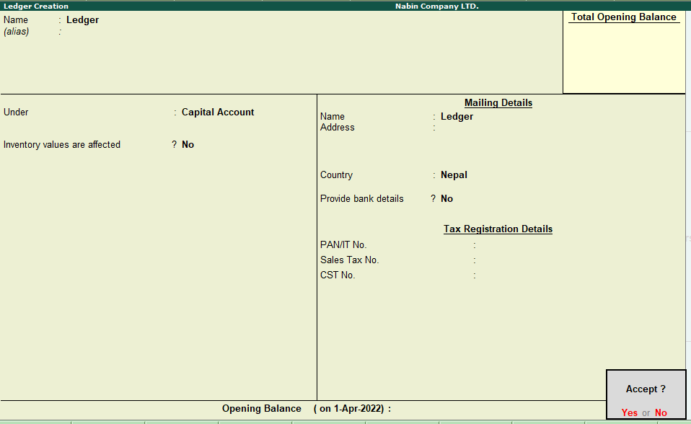

**Display single ledger**

To display a single ledger, the following steps are followed:-

Gateway of tally > account info> ledger > single ledger> display

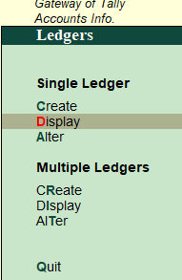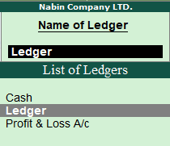

After that click on the one ledger to one ledger among the list to view the detail.

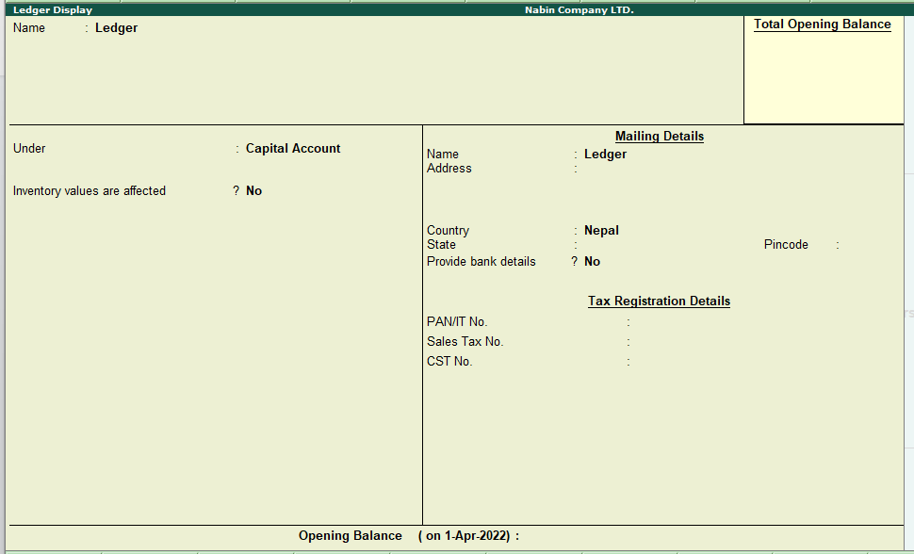

**Alter ledger**

Alter feature is used to change the name of the ledger head, and transaction, and can delete the ledger.

**Alternation of single ledger**

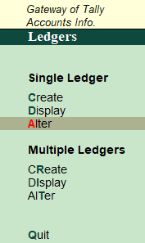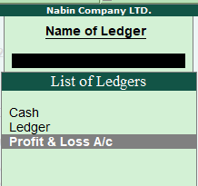

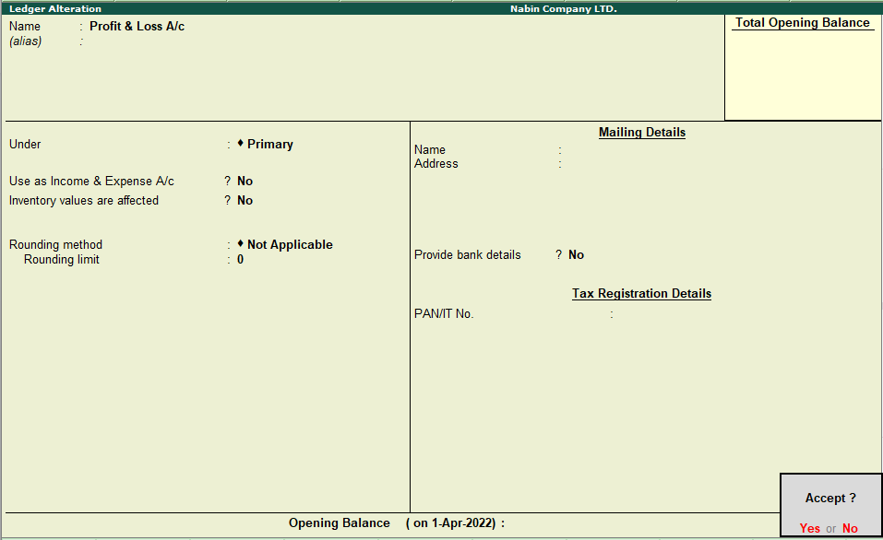

**Multiple ledger Creation**

In multiple ledger, we can create multiple ledgers under the same group at a time.

Steps

* Go to the gateway of tally
* Go to account info
* Click on the ledger
* Create multiple ledgers



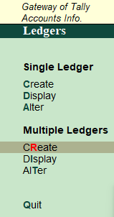

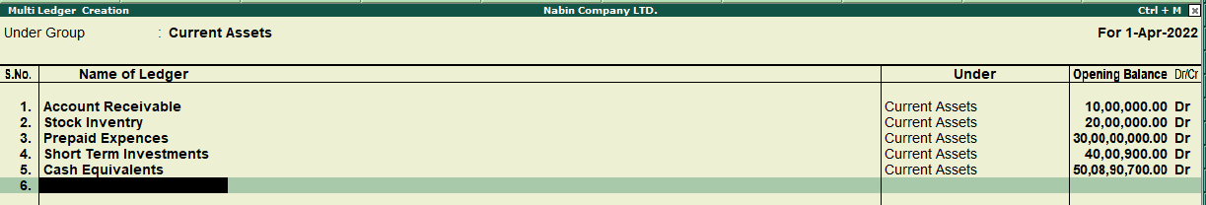

**Display multiple ledgers**

To display a single ledger, the following steps are followed:-Gateway of tally > account info> ledger > multiple ledgers > display

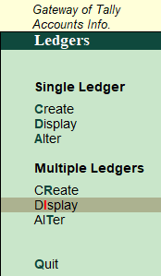

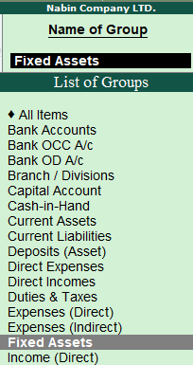

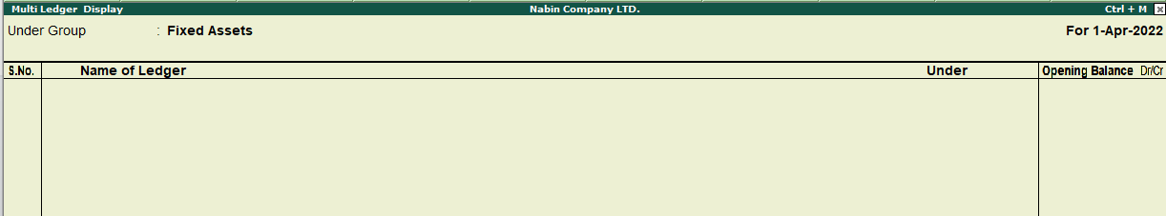

**Alter ledger**

Alter feature is used to change the name of the ledger head, and transaction, and can delete the ledger.

**Alternation of multiple ledgers**

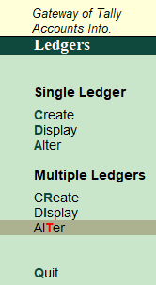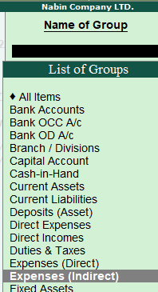

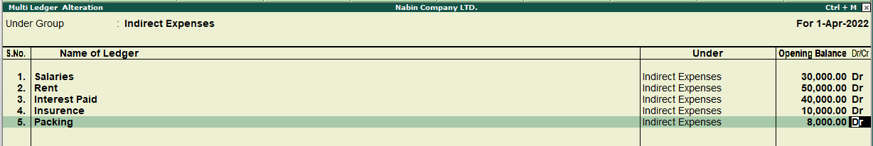

Multiple ledgers and single ledger alteration are the same but the difference is in multiple alterations we can alter multiple ledgers.